Dominick Hernandez

Ali Shaykhian, Ph.D.

CS 330

10/18/24

Final Project

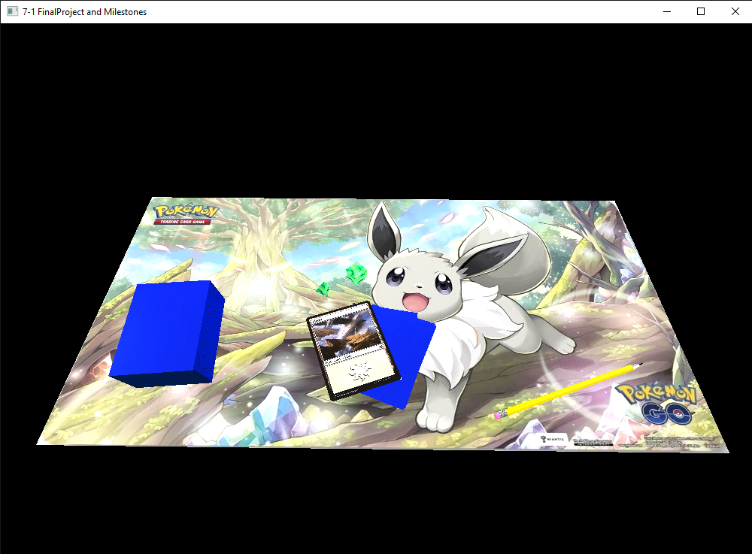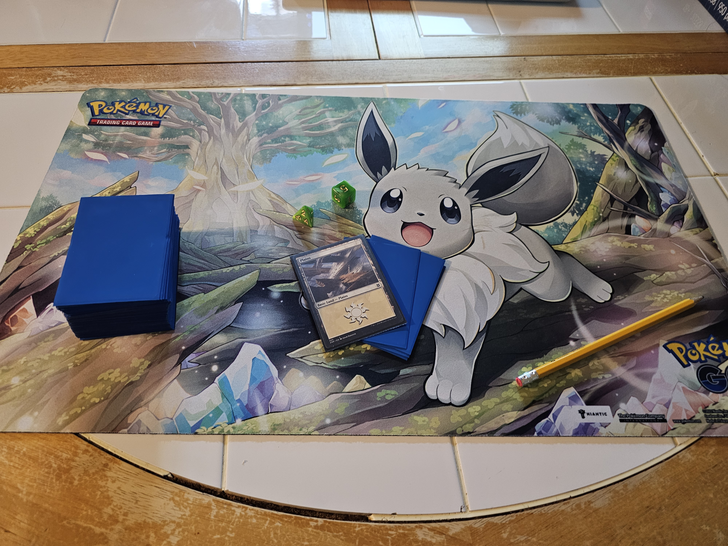

1. **Justify development choices for your 3D scene**.

The objects I chose were objects I already had on the table from game night, they fulfilled all the necessary requirements and seemed easy enough to model while still looking natural. I had a hard time working with the materials and trying to figure out what lighting combinations would look natural, in the end, I spend quite a bit of time simply modifying different materials and combinations of lighting.

1. **Explain how a user can navigate your 3D scene**.

The WASD keys are used to control the forward, backward, left, and right motion. The Q and E keys are used to control the upward and downward movement respectively. The mouse scroll can be used to adjust the speed at which the camera travels. Lastly the O and P keys switch between orthographic and perspective views.

1. **Explain the custom functions in your program that you are using to make your code more modular and organized**.

I added functions to separate the different sections of objects being rendered. One for the dice, one for the cards, and one for the pencil. This was extremely helpful as I could easily separate them and keep track of which sections went to what objects without scrolling through a heap of code, I made sure to add them to be called in the render scene function, which also served to keep the function organized. I also added sections for setting up the lights and materials. I then called them all in the prep scene function that is called when the application first starts.